CS4375 Fall 2025 Homework Report
<Chris Lopez> Submitted on <12/4/2025>
<celopez8@miners.utep.edu>

Semaphores for xv6.

Task 3. Implementation of sem_init(), sem_wait(), sem_post(), and sem_destroy().

For Task 3, I implemented sem_init(), sem_wait(), sem_post(), and sem_destroy() using a semaphore table in the kernel. In sem_wait(), I used a process that acquires the semaphore’s lock and checks the count. If the count was 0 then the process would call sleep() on the semaphore in order to block it until it became available, then it would decrease the count. In sem_post(), the count is incremented under the lock, and wakeup() is called to unblock any waiting processes. Sem_init() gives a semaphore and sets the initial count, while sem_destroy() checks if the semaphore is invalid. The main challenge I faced was trying to avoid deadlocks and safely moving the index of the semaphore from the user and kernel space using copyin() and copyout().

Task 4. Readers–Writers with xv6 Semaphores.

For Task 4, I implemented reader() and writer() with the semaphores mutex and wrt from the shared rw_t structure. Each reader acquires mutex to increase readercount, the first reader will lock wrt to block writers and the last reader unlocks wrt after decrementing readercount. This will allow for multiple readers to read at the same time while making sure that the writers have exclusive access. Each writer will acquire wrt before it beings updating the shared value and then releasing it afterwards, making sure that no readers or writers are in the critical section at the same time.

Reader:
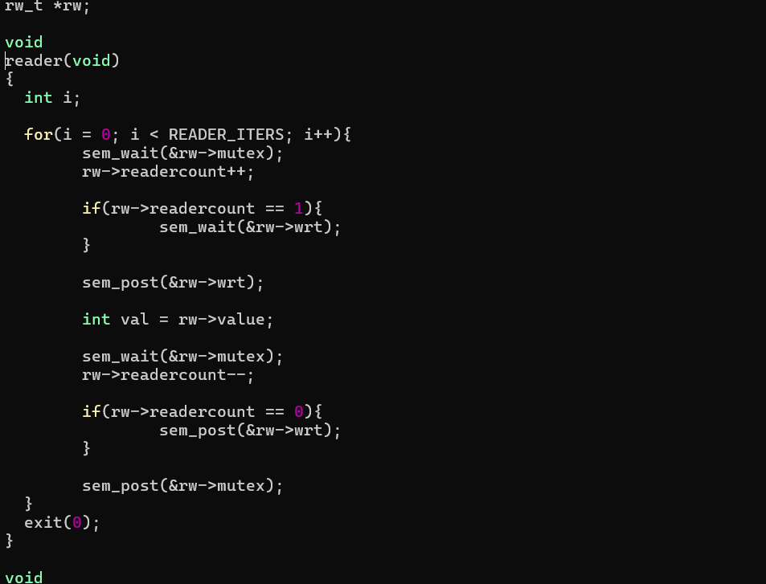
Writer:
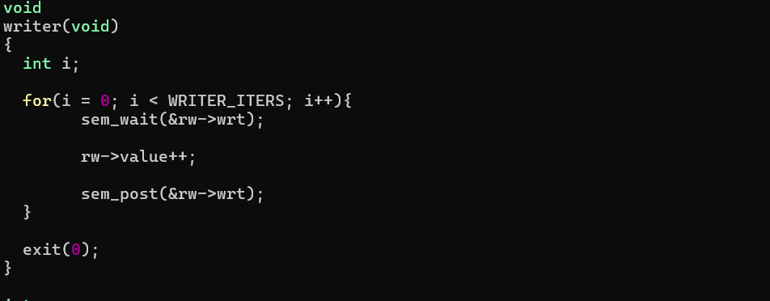

Summary:

From this lab, I was able to learn how to implement and use semaphores in xv6 to be able to synchronize processes. As with previous labs I gained more experience in creating system calls and updating the files accordingly to make those calls available. I also learned how to share data safely and in a relatively easy way and using sleep() and wakeup() for blocking and waking processes. Finally, while understanding and writing the code I needed for the reader and writer’s functions it helped me understand how to allow concurrent reads while also making sure that writers had exclusive access, also helping me realize practically how deadlocks can happen.

